Assignment 2

1. **Connect to the Store Sales Data and do the following: -**
   1. Remove all the blank rows.
   2. Update the column header if they are not updated
   3. Create a text table and show the sales in terms of
      1. Customers
      2. Product Category
      3. Regions

Ans.

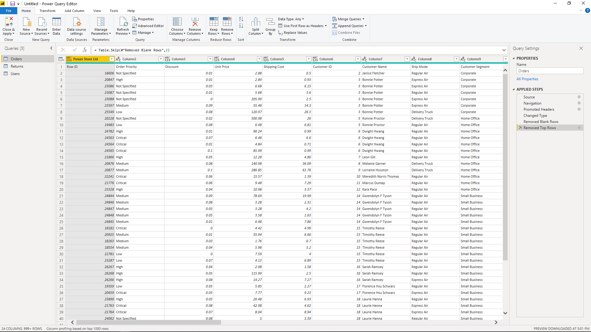

a

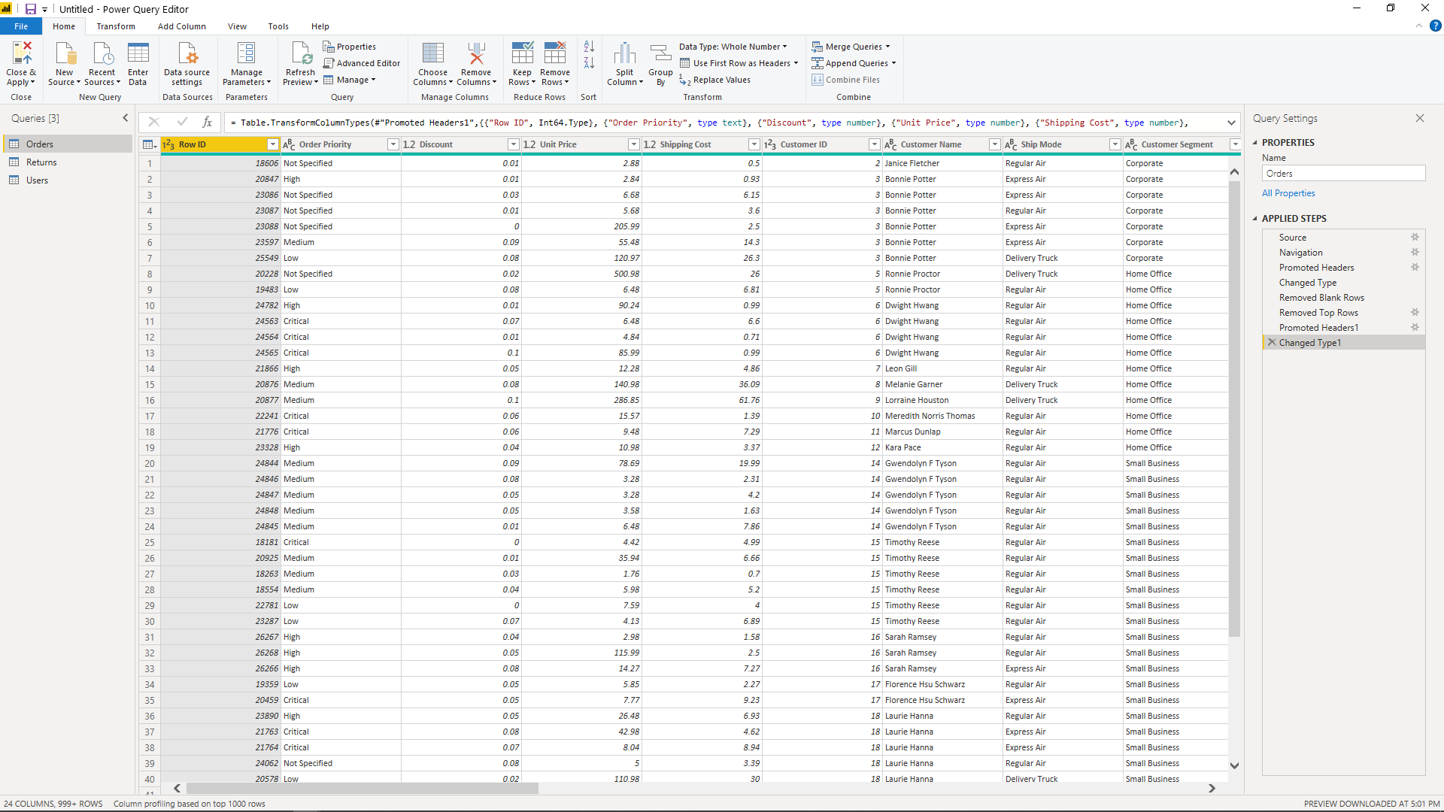

b

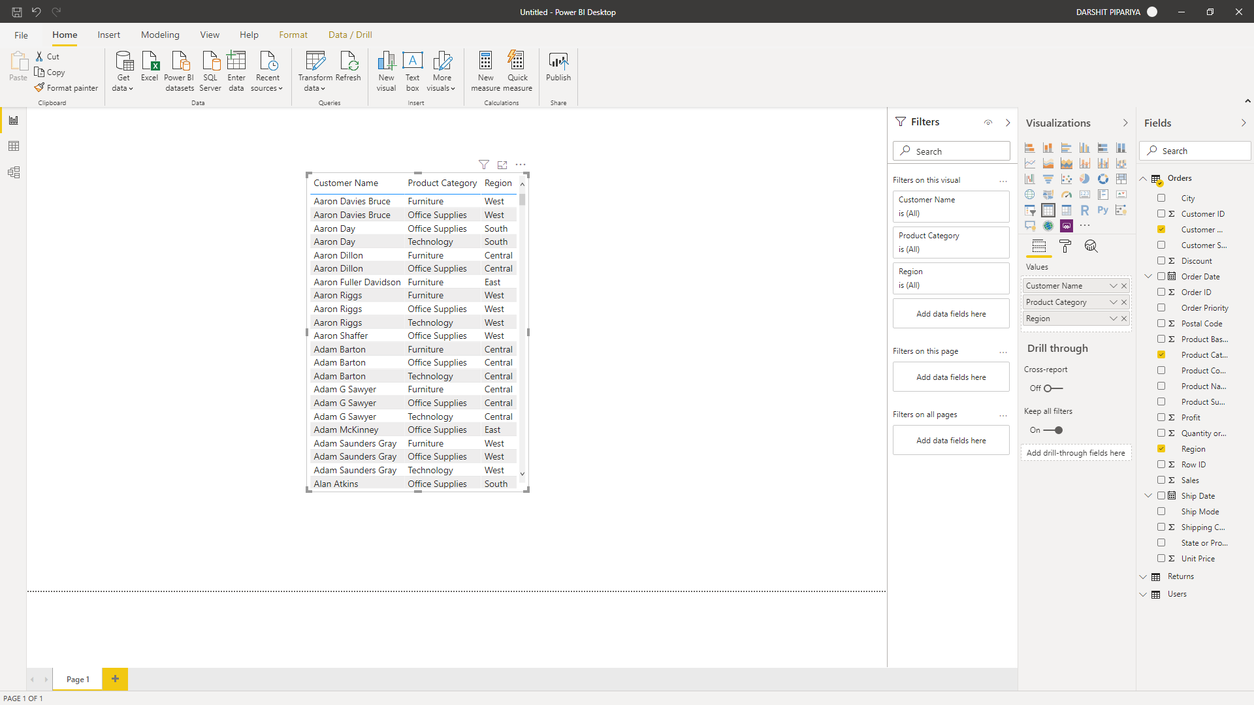

C

1. **Create a line and Clustered Column Chart showing the Sales and Discount as per the State or**
   1. Format the bars and line with different colors
   2. Which state has the highest sales in terms Technology

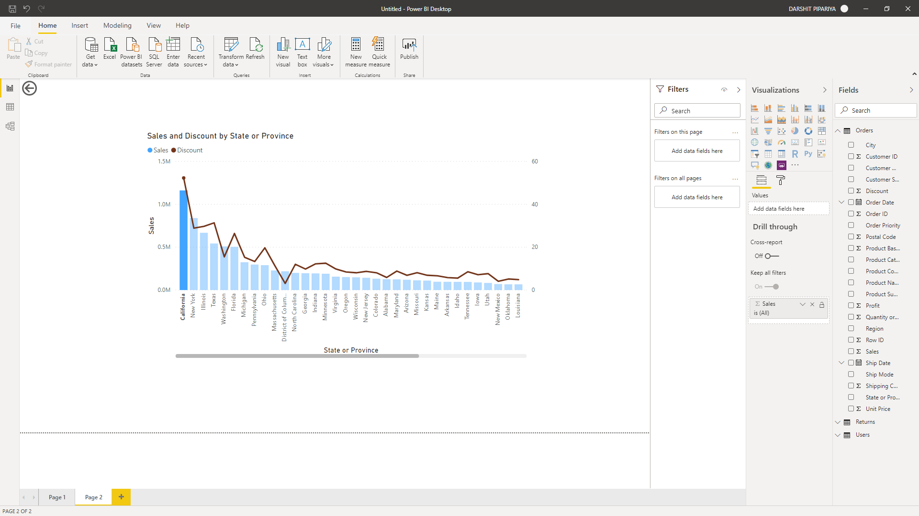

1. **Create a Donut Chart showing sales in terms of Product category**

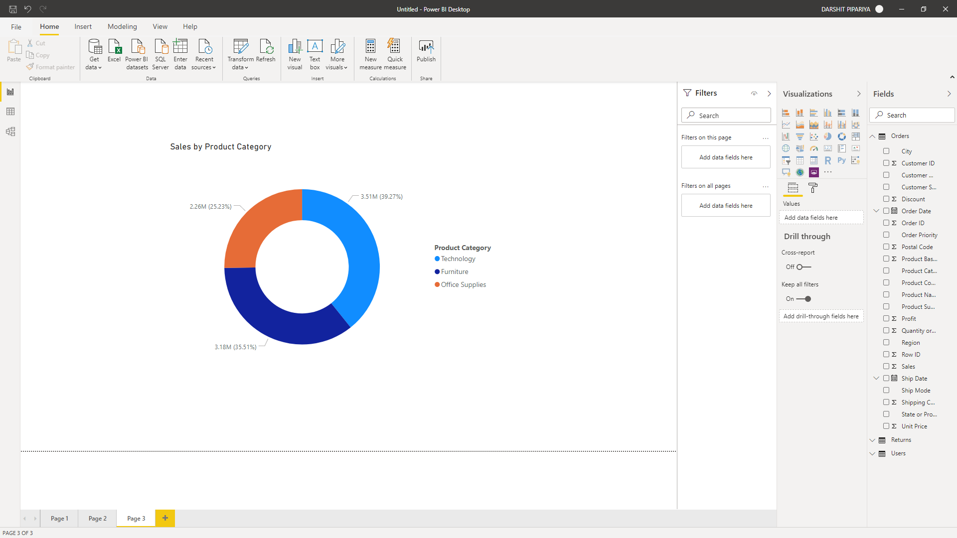

1. **Create a Slicer and show the regions in dropdown. See how all the visuals mentioned above behaving when a particular region is selected.**

